How to Invite Users to Your Organisation and Assign them an Organisation Role

This guide contains 3 sections:
- are not sure what Organisation Role to give each user;
- want to skip this step and add users to your organisation after the initial account onboarding;
- want to help your colleagues finish setting up their Due Account after being added to the organisation.

1. Overview
Before adding a user to a project, you need to add them to the relevant organisation. If you have more than 1 organisation, ensure you are adding users to the correct organisation.

2. Adding Users to Your Organisation
As an account Owner or Admin, you can add new users to your organisation as follows:
- If you are part of more than one organisation, select the correct organisation you want to add users to.
- Click organisation Settings on the navigation bar on the right-hand side.
- Click Add team member to add a new user to your organisation by inserting their full name, email and selecting an organisation role.

💡 Tip — Not sure what Organisation Role to assign?
Refer to the table in Section 3 below for guidance on which role to assign to each type of team member.

3. What Organisation Role Should I Give My Team Members?
You have the following options to choose from:
- Owner
- Admin
- Member
- Client

Use the table below when deciding which role to assign each person when inviting them to the organisation. Assigning the correct organisation-level role ensures people have exactly the access they need — no more, no less.

Organisation Role | Permissions
Owner | Full access to all organisation settings, billing, all projects and all members. The person who signed up is automatically the Owner of the Account. There can be more than 1 owner if needed.
Admin | Can manage organisation members and settings, create and manage all projects, but cannot access billing. Suitable for senior brokers or IT administrators.
Member | Can access projects they are specifically invited to. Access level to project is based on the project role assigned. Cannot manage organisation settings or invite organisation members.
Client | Highly restricted. Intended for buyers or external third parties who should only see what is explicitly shared with them in the project.

1.3 What if you are already part of another Organisation?
Before creating your Due account as set out in this guide, you may already be a part of another organisation. If this is the case, we recommend referring to the below supplementary user guide to learn how to navigate between organisations.

💡 Supplementary User Guide
If you are already part of another organisation, refer to the supplementary user guide on “How to navigate more than 1 Organisation”.

Due Business Broker Onboarding Manual | Supplementary: How to Invite Users to Your Organisation

Due
New User Account Setup Guide
Setting up your account and accessing your project documents

Introduction
You have been invited to join an organisation on Due — a purpose-built data room platform for secure document sharing and due diligence. This guide will walk you through the complete setup process, from activating your account through to accessing documents in your assigned project.

By the end of this guide you will have:
- Created a secure password and activated your Due account
- Logged in to the Due platform
- Located your assigned project
- Accessed the Data Room to upload or view documents

Before you begin
You will need the invitation email sent to you from info@doitwithdue.com.
Keep the email open — you will click a link inside it to get started.
If you cannot find the email, check your junk or spam folder.

Step 1 — Accept Your Invitation
The first step is to open the invitation email sent to you by Due and click the activation link.

Step 1: Open the invitation email and click 'Create your account'
- Locate the invitation email in your inbox. The sender will appear as System Account – Due (via Due) from info@doitwithdue.com.
- Open the email. You will see a message saying 'You're invited to join Due'.
- Click the blue 'Create your account' button in the body of the email (shown with the red arrow below).
- If the button does not work, copy and paste the link shown below the button directly into your browser's address bar.

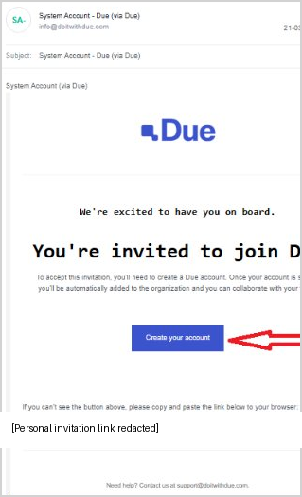
Screenshot: The Due invitation email — click 'Create your account' to proceed
Tip: The invitation link is unique to you and can only be used once. Do not share the email or link with anyone else.

Step 2 — Create Your Account and Password
Clicking the link will open the Due 'Create Your Due Account' page in your browser. Your email address will already be pre-filled.

Step 2: Set a secure password
- Review your email address shown in the Email field to confirm it is correct.
- Click into the Password field and type a new password for your account.
- Re-enter the same password in the Confirm Password field (as shown below).
- Once both fields match, click the blue 'Create Account' button.

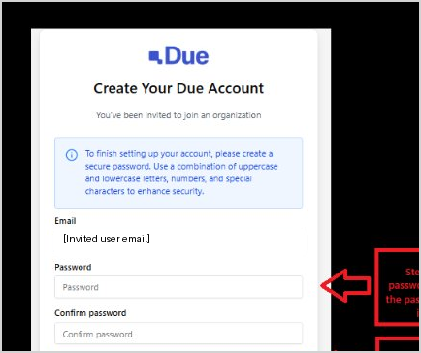
Screenshot: Enter and confirm your password, then click 'Create Account'

Your password must meet the following requirements:
Requirement | Detail
Uppercase letters | At least one uppercase letter (A–Z)
Lowercase letters | At least one lowercase letter (a–z)
Numbers | At least one number (0–9)
Special characters | At least one special character (e.g. ! @ # $ %)
Length | A minimum of 8 characters is recommended

Important: Store your password securely. Due cannot retrieve your password if it is lost. Use a password manager or write it down and store it safely.

Step 3 — Access Your Dashboard and Project
After clicking 'Create Account', you will be automatically logged in and taken to your Due Dashboard.

Step 3: Navigate to your assigned project
- On the Dashboard, you will see a greeting and a list of projects you have been added to on the left-hand side under 'Projects'.
- Locate your project name in the sidebar (for example, 'Madison Relocation to Australia 2026').
- Click on the project name to open it.

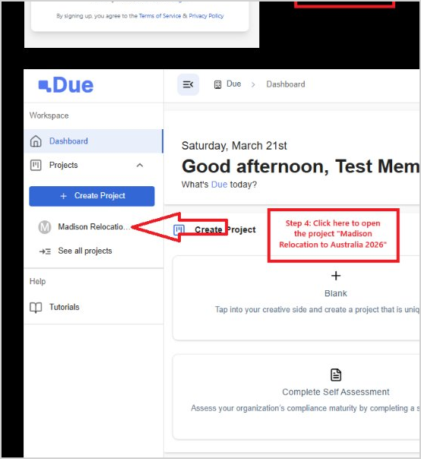
Screenshot: The Due Dashboard — click your project name in the left sidebar to open it
Note: If you do not see any projects listed, contact the person who invited you. They may need to confirm that your account has been added to the correct project.

Quick Reference Summary
Use the table below as a checklist as you complete your account setup.

# | Action | Where to find it
1 | Open invitation email and click 'Create your account' | Email from info@doitwithdue.com
2 | Enter and confirm your password, then click 'Create Account' | Account creation page (browser)
3 | Click on your project name in the sidebar | Due Dashboard
4 | Click 'Data Room' in the project navigation bar | Project page — top navigation

Need Help?
If you encounter any issues during the account setup process or have questions about accessing your project, please reach out to the Due support team.

Contact Due Support
Email: support@doitwithdue.com
Website: doitwithdue.com

© 2026 Due. All rights reserved.

